Unity and Oculus Integration plugin SOP

Created by Linfeng Wu, updated on 08/03/2023

Instructions for using Oculus Integration within Unity for Oculus app development.

Note: Before you read the SOP, it would be helpful to know some basics about Unity. Please refer to this [link](https://docs.google.com/document/d/1E8PTkWw2107qIO-aY1grQ6cbp5LUGhr2/edit) for information.

Downloads:

Oculus Integration: <https://assetstore.unity.com/packages/tools/integration/oculus-integration-82022>

Unity: <https://unity.com/download>

Note: The minimum supported Unity version for the Oculus Integration is 2021.3 LTS.

Steps:

1. Unity project set up.

* Follow the instructions to create a Unity project. In Unity, make sure you installed the Android Build Support (Open JDK, Android SDK & NDK Tools).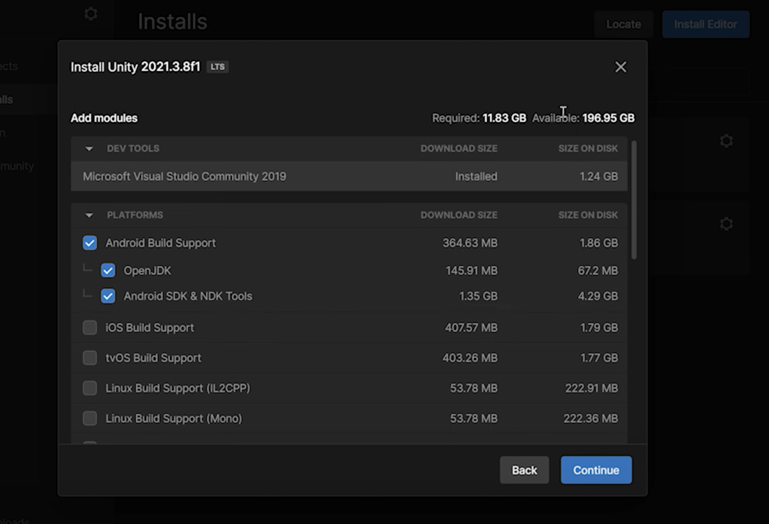
* Open the project in Unity editor, go to File->Build Settings, change the platform to Android, set the Texture Compression type to ASTC and then click “Switch Platform”.

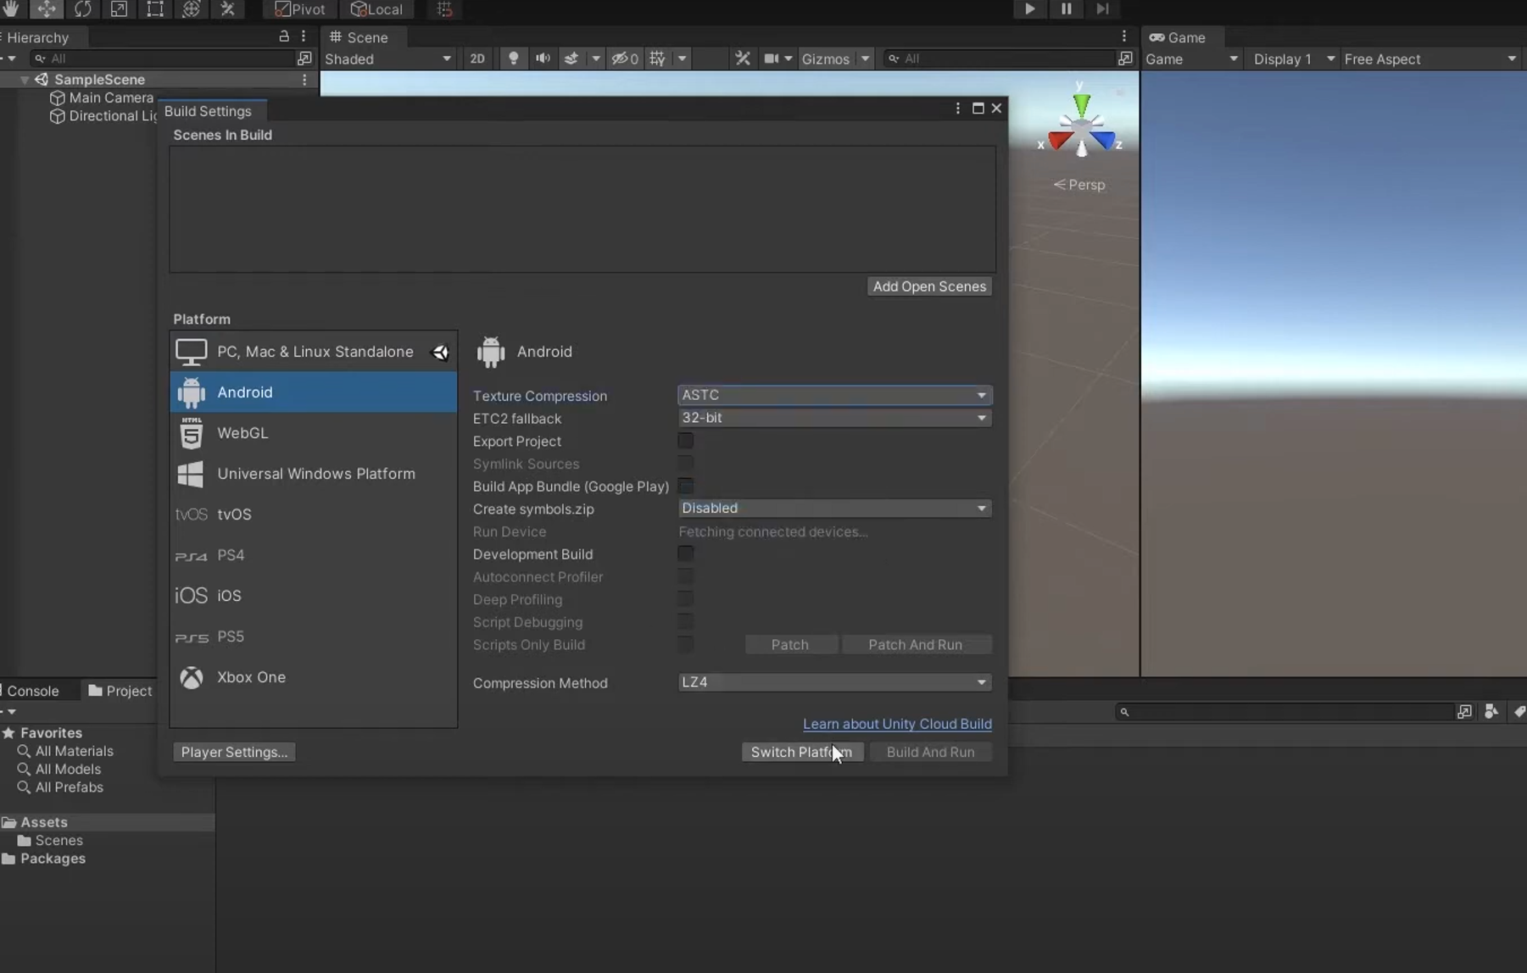

* Go to Edit->Project Settings, find the XR Plugin Management tab, and click the “Install XR Plugin Management”. And then check the Oculus box.

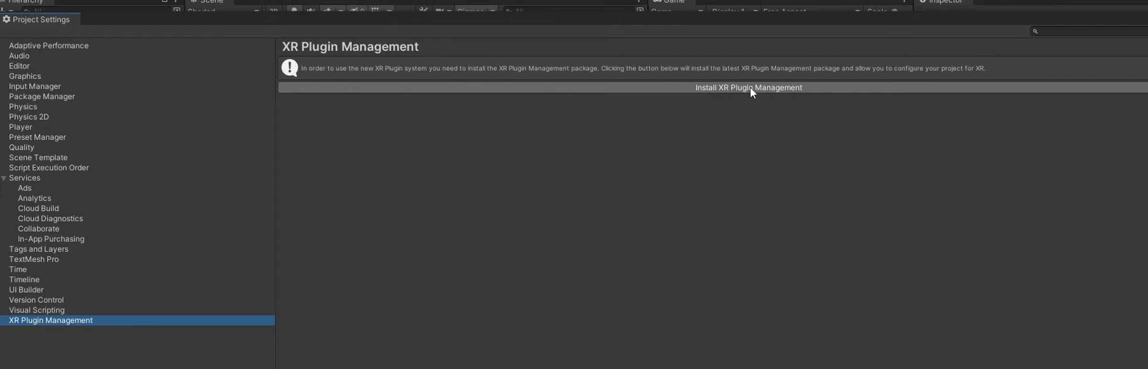

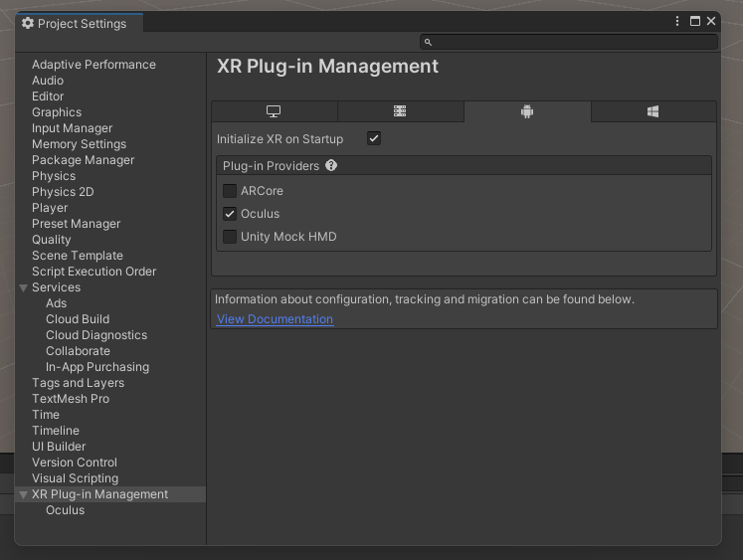

1. Oculus Integration asset importation. After the Unity project is created, go to unity asset store to search for Oculus integration ([Oculus Integration](https://assetstore.unity.com/packages/tools/integration/oculus-integration-82022%23description)). Click “Add to My Assets.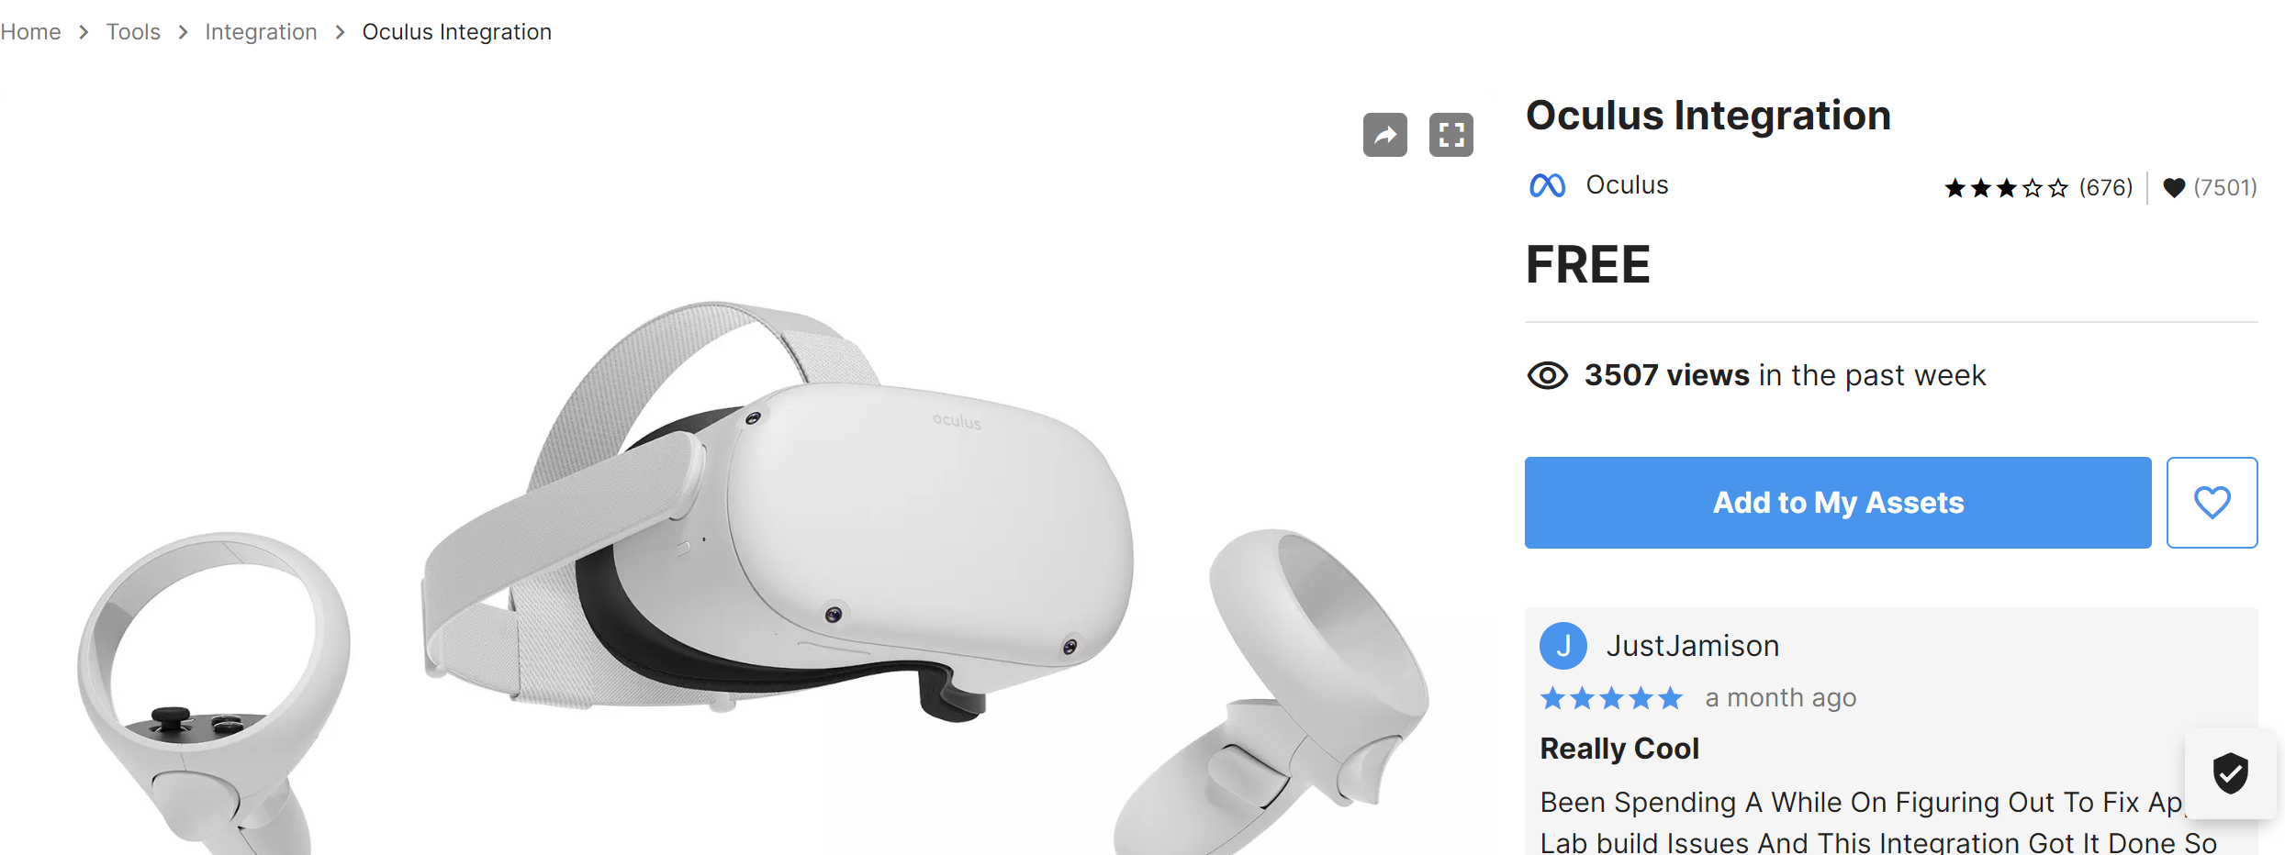

After you logged in, click “Open in Unity” to go to Unity editor to import the asset to the Unity project.

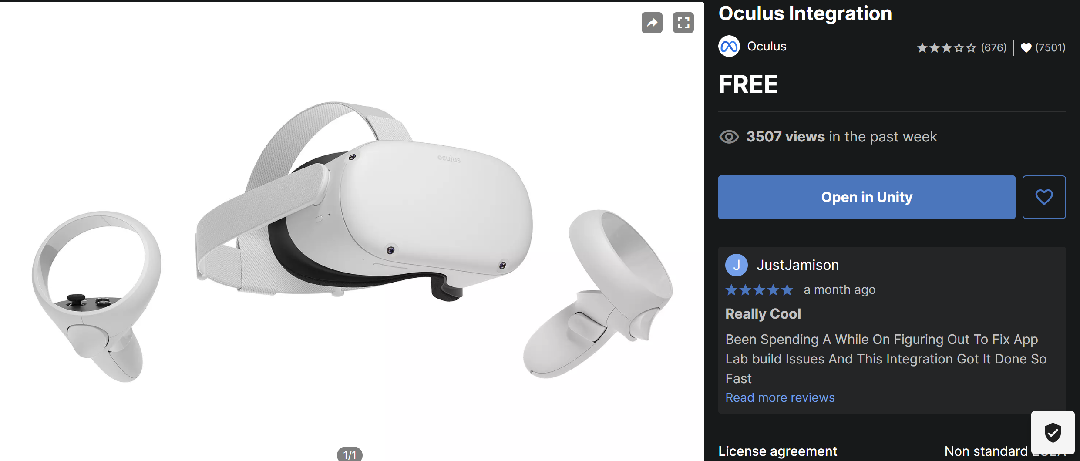

Another way to import the oculus integration asset is to go to Unity editor, Click Window->Package Manager, search for Oculus integration and import all.

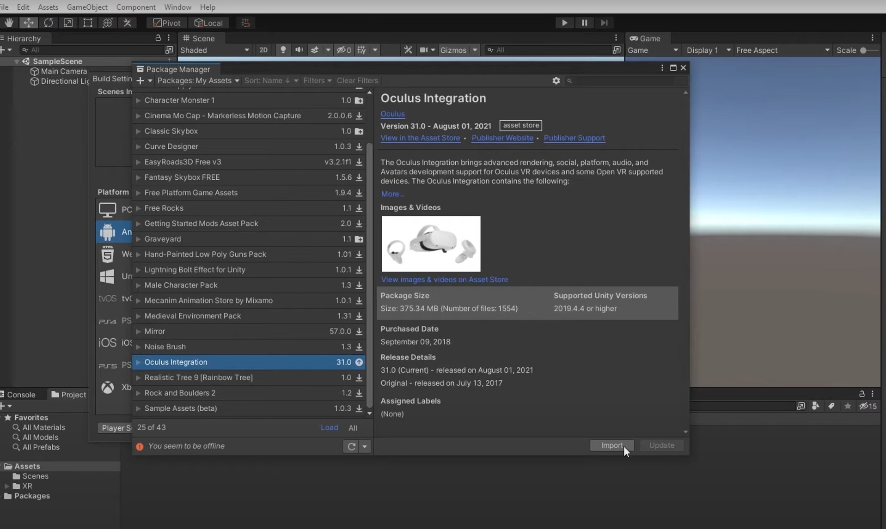

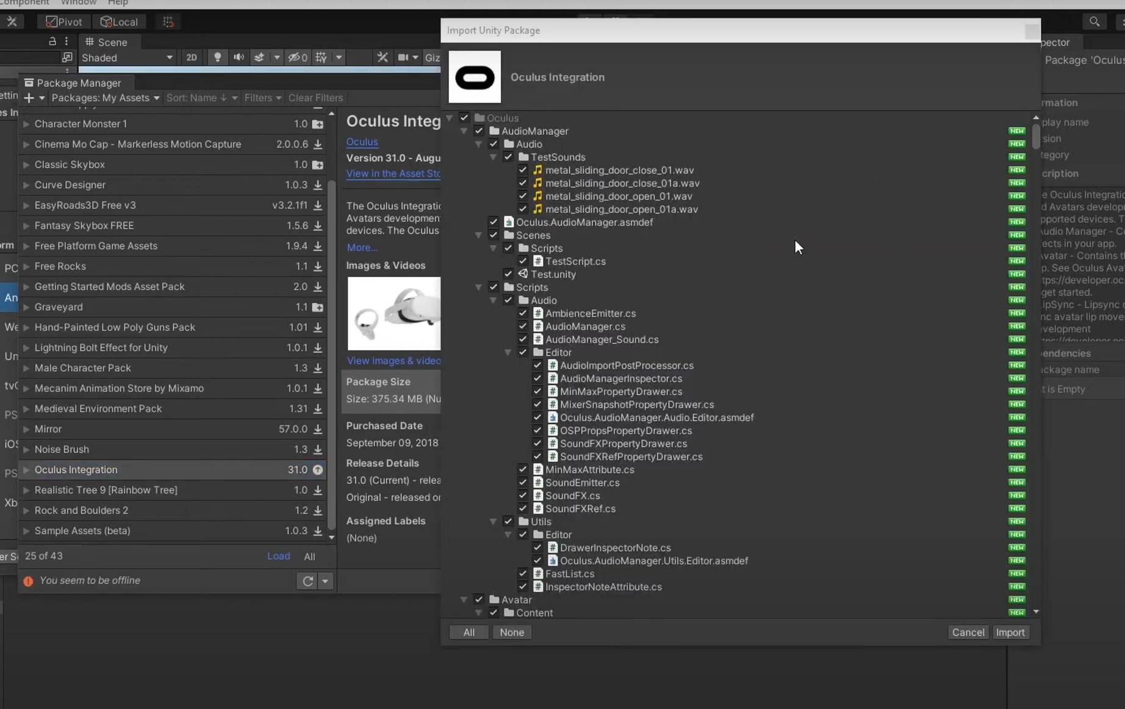

Click “No” when you are asked about “Update Oculus Utilities Plugin”.

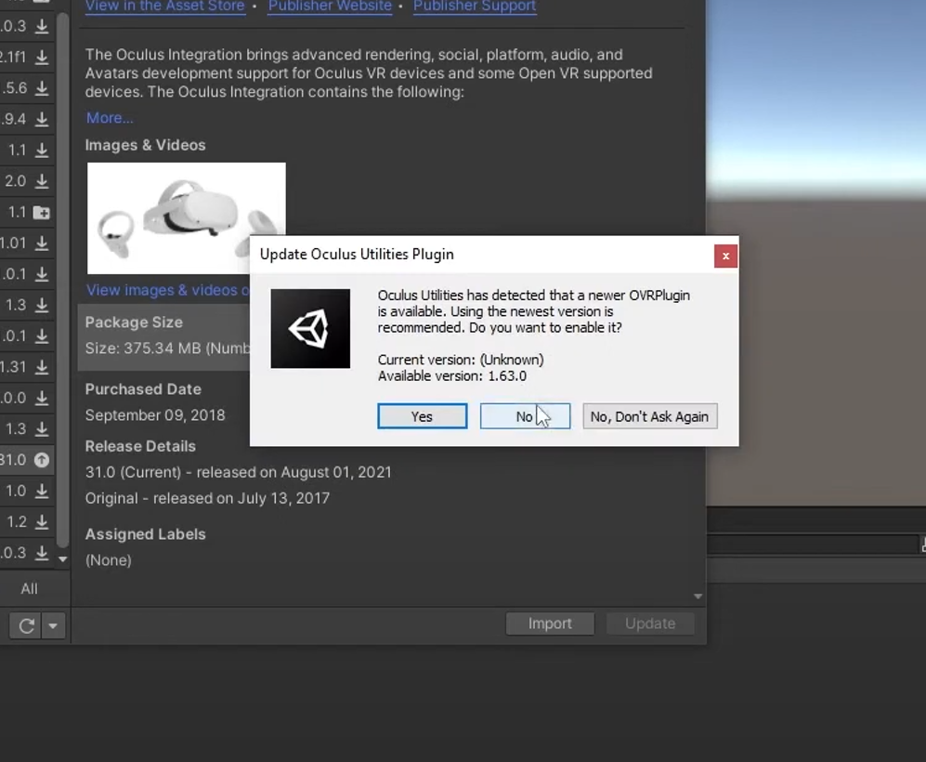

1. OVRCameraRig set up. After you imported the Oculus Integration asset, you can search for the OVRCameraRig Prefab and add it to the Unity project by dragging it to the Hierarchy.

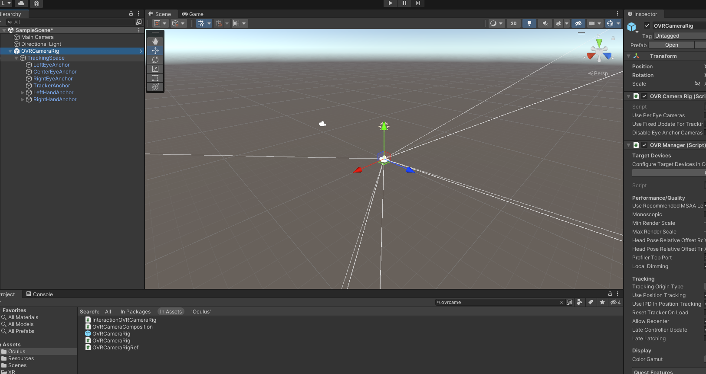

1. OVRControllerPrefab set up. Search for the OVRControllerPrefab in asset and add it to the project by dragging it to the LeftHandAnchor and RightHandAnchor as a child object in the Hierarchy.

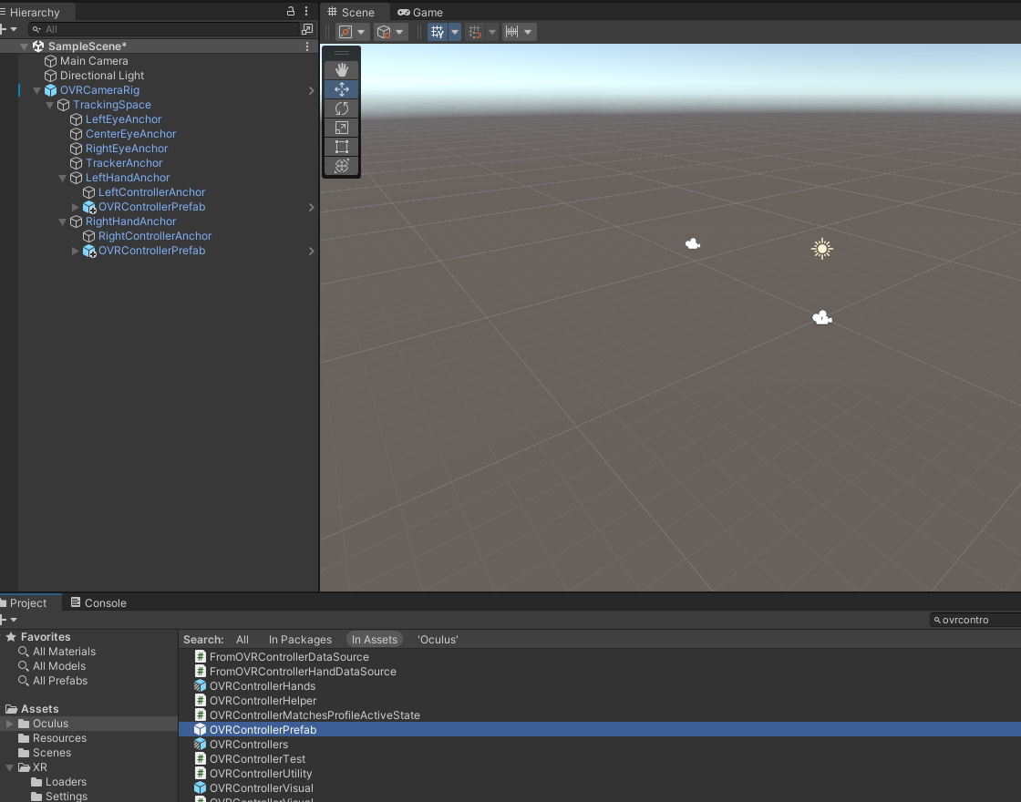

For the OVRControllerPrefab under LeftHandAnchor, set the Controller type to L touch. For the OVRControllerPrefab under RightHandAnchor, set the Controller type to R touch. So far, the Unity project with Oculus Integration is created.

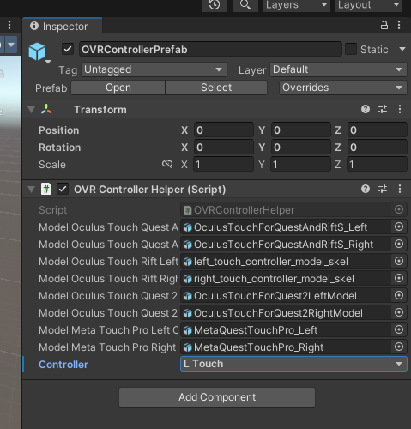

1. An example to show a button input from the controller. Create a script called SOPexample and attach it to a gameobject called Test in the Hierarchy. For more details for controller interactions, please refer to this [link](https://developer.oculus.com/documentation/unity/unity-ovrinput/).

